Guidelines for authors and sample manuscript

Author KIKAI*, Author YAMA* and Author UMI**

*Japan Society of Mechanical Engineering

35 Shinanomachi, Shinjuku-ku, Tokyo 160-0016, Japan

E-mail: journal@jsme.or.jp

**Department of Mechanical Engineering, Kikai University

35 Shinanomachi, Shinjuku-ku, Tokyo 160-0016, Japan

1. Introduction

In preparing the extended abstract with Microsoft (MS) Word, please read this sample manuscript carefully.

Please prepare a maximum three-page extended abstract (both MS Word and PDF), and send them to the symposium secretary by e-mail: [mmdconf19-2@jsme.or.jp](mailto:mmdconf19-2@jsme.or.jp) (Yuji Ichikawa, Tohoku University). The deadline of submission is July 1, 2019.

The recommended structure of a manuscript is as follows: Introduction (purpose of the research, significance of the research supported by a literature survey, outline of contents, and so on), Main body of the text (theoretical analysis, method and results of experiment, interpretation of results and discussion, and so on), Conclusion (conclusions obtained through the research), Acknowledgment, Appendixes, References.

Apart from the above example, a different structure of manuscript may be accepted if it is the most suitable and effective style for the contents of the manuscript.

2. Title, authors' name and affiliations

Only the first word of title should be capitalized. The names of authors should be placed immediately below the title. The given names and family names should be spelled out with each character of family names capitalized. In the address (all authors’ addresses should be listed except when multiple authors have the same address), give the prefecture, ward, city and postal code. Give "the country name" at the end of the address, and provide the e-mail address of the contact person. Do not provide e-mail addresses of authors other than the contact person.

3. Headings

The main body of the text should be suitably divided into sections (and if necessarily subsections), each with a heading. For instance,

4. Compensation of flow disturbance using estimated signal

4.1 Estimation of flow disturbance

4.1.1 Axisymmetric disturbance

5. Figures, tables, photographs and online supplements

Figures and tables should be presented with sufficiently informative captions. Every caption should be complete and intelligible by itself without references to the text. See an example shown below:

**Table 1** Examples of writing numbers.

|  |  |
| --- | --- |
| Recommended | Not recommended |
| 0.357 | .357 |
| 3.141 6 | 3.141,6 |
| 3.141 6×2.5 | 3.141 6・2.5 |
| 3.141 6×103 | 3.141 6E+3 |
| 1000 or 1 000 | 1,000 |

**Table 2** Examples of writing a square root and a fraction.

|  |  |
| --- | --- |
| Recommended | Not recommended |
|  | √ |
|  |  |

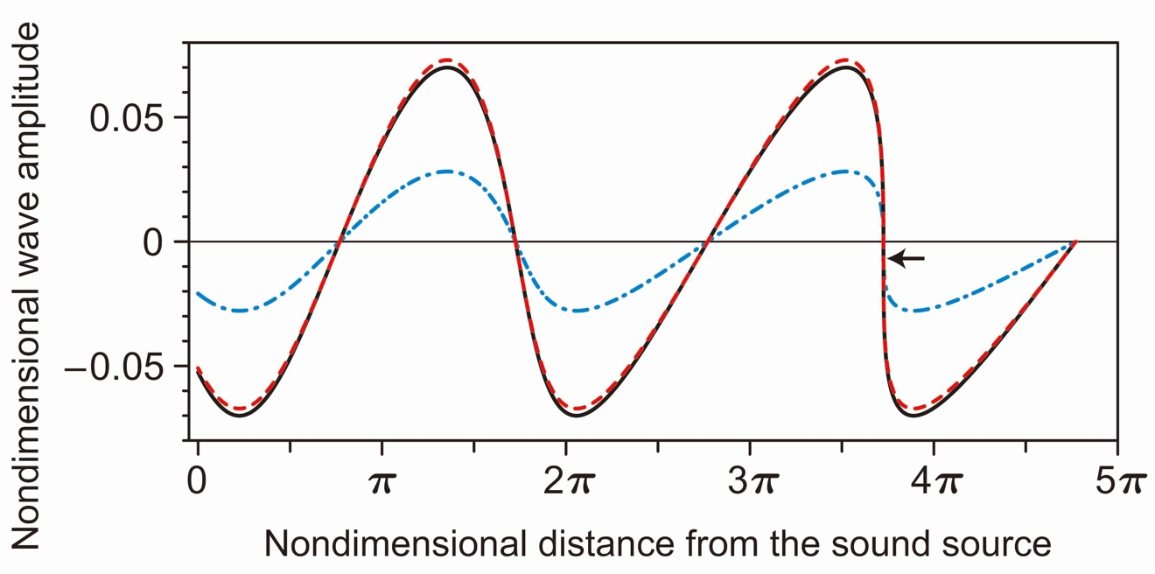

**Fig. 1** The nonlinear propagation of plane acoustic wave radiated by the sound source. Using the exact solution of the system of Euler equations, the nondimensional profiles of fluid velocity, acoustic pressure and temperature variation at the time of shock formation are plotted with the solid (black), dashed (red) and dash-dotted (blue) curves, respectively. As the wave propagates, the nonlinear effect accumulates to distort the profile, and ultimately leads to the formation of shock wave. The shock formation point is denoted by a small arrow in the figure.

6. Citation of equations, references, tables, figures and others in the text

Within a sentence, an equation is cited with the number and "Eq." for example, "Eq. (1)," and at the beginning of a sentence, it should be written out as "Equation (1)." Within a sentence, a figure should be cited with "Fig.," for example, "Fig. 1," and at the beginning of a sentence, it should be written out as "Figure 1."

 (1)

 (2)

 (3)

 (4)

Italic type must be used for physical and mathematical symbols. Upright Roman type may be used for differentiation operator d as shown in Eq. (1).

7. References

Citations in the text are indicated by author’s last name and year with the list of references arranged in alphabetic order: for example, (Ahrendt and Taplin, 1951) or the book by Ahrendt and Taplin (1951). For a reference from three or more authors, the citation in the text is indicated by the first author's name followed by "et al." and the year: for example, (Takeuchi et al., 2006). If a reference is not written in English, authors are required to translate the title into English and indicate the original language as "(in Japanese)," for example. See an example below.

References

Ahrendt, W. R. and Taplin, J. F., Automatic Feedback Control (1951), p.12, McGraw-Hill.

International Federation of Library Associations and Institutions, Digital libraries: Resources and project, IFLANET (online), available from <http://www.ifla.org/II/htm>, (accessed on 30 November, 1999).

Kameyama, H., Production method of thermal conductive catalyst, Japanese patent disclosure H00-100100 (1990).

Karin, P. and Hanamura, K., Microscopic visualization of PM trapping and regeneration in a diesel particulate catalyst-membrane filter (DPMF), Transactions of Society of Automotive Engineers of Japan, Vol.41, No.1 (2010a), pp.103–108.

Karin, P. and Hanamura, K., Microscopic visualization of particulate matter trapping and oxidation behaviors in a diesel particulate catalyst-membrane filter, Transactions of Society of Automotive Engineers of Japan, Vol.41, No.4 (2010b), pp.853–858.

Keer, L. M., Lin, W. and Achenbach, J. D., Resonance effects for a crack near a free surface, Transactions of the ASME, Journal of Applied Mechanics, Vol.51, No.1 (1984), pp.65–70.

Nagashima, A., New year's greeting, Journal of the Japan Society of Mechanical Engineers, Vol.108, No.1034 (2005), pp.1–2 (in Japanese).

Tagawa, A. and Yamashita, T., Development of real time sensor for under sodium viewer, Proceedings of the 19th International Conference on Nuclear Engineering (ICONE-19) (2011), Paper No. ICONE19–43187.

Takeuchi, S., Yamazaki, T. and Kajishima, T., Study of solid-fluid interaction in body-fixed non-inertial frame of reference, Journal of Fluid Science and Technology, Vol.1, No.1 (2006), pp.1–11.

Takeuchi, Y., Ultraprecision micromilling technology, Transactions of the Japan Society of Mechanical Engineers, Series C, Vol.71, No.701 (2005), pp.1–4 (in Japanese).

The Japan Society of Mechanical Engineers ed., JSME Data Handbook: Heat Transfer (1979), p.123, The Japan Society of Mechanical Engineers (in Japanese).

Tsutahara, M. Tamura, A. and Kataoka, T., A study of SIS of surfactant by the finite difference lattice Boltzmann method, Proceedings of the 16th Computational Mechanics Conference (2003), pp.121–122 (in Japanese).

Watanabe, T., Sakai, Y., Nagata, K., Terashima, O., Ito, Y. and Hayase, T., DNS of turbulent Schmidt number and eddy diffusivity for reactive concentrations, Transactions of the JSME (in Japanese), Vol. 80, No. 809 (2014), DOI:10.1299/transjsme.2014fe0008.