999999
Contribution template (Please remove red boxes when you send this contribution.)
Template for a 1- to 2-pages (A4-size) contribution for IWEE2019
Please indicate * for regular members of JSME and ** for student members of JSME if applicable.
Please insert your presentation number
25- 28 June 2019, Okinawa, Japan (14 pt, bold)
G. Kikai^{1,2,*}, B. Kankyo^{3,**} and R. Bankoku¹
¹Department of Mechanical Engineering, Kikai University, Tokyo, Japan
²Environmental Engineering Division, Japan Society of Mechanical Engineers, Tokyo, Japan
³ Bankoku Shinryokan Resort, Nago, Okinawa, Japan
e-mail: kikai@jsme.ac.jp (email, contact person only, 10.5pt)
Keywords: Include keywords on a single line, separated by commas.

All contributions must be submitted in English (Title: Times New Roman, 14 pt, bold. Authors, Affiliations, Keywords, Text: Times New Roman, 10.5 pt) and the maximum length including figures is A4 two pages. The abstract book will be printed in black and white.
Do not include page numbers. A caption should be written under each figure and above each table as in Fig. 1 and Table 1. References must be numbered and referred to in the text⁽¹⁾. Equations are written as:
$τ= μ\frac{du}{dy}$ (1)
You are kindly asked to submit your presentation(s) through the IWEE2019 website (https://www.jsme.or.jp/env/iwee/2019/registration.html) before the deadline of February 1, 2019. In the presentation submission, please include the authors’ details, the name of the speaker, the title, a 100-word abstract, the session number and the presentation type (oral/poster/either), and submit by February 1, 2019. The submission of contributions (A4, 1-2 pages) using this template must be submitted through the same website by April 15th, 2019.
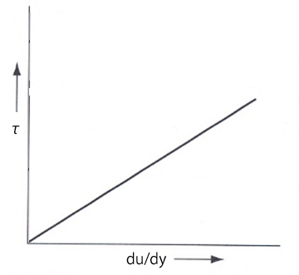
All accepted contributions will be published in the IWEE2019 proceedings and made available for download on the IWEE2019 website from June 25, 2019. A speaker must register for the IWEE2019 before April 15, 2019 for presentation.
Fig. 1. Relationship between shear rate and shear stress.
All figures, tables and graphs should be embedded within the text to which they are referred (not linked). Reference⁽¹⁾ should be put at the end. Appendices should be avoided. You may include an Acknowledgements placed after the Conclusions and before the References.
All contributions should be carefully proofread, then saved and submitted as .pdf documents. It is the authors’ responsibility to make sure the .pdf displays correctly.
(1) G. Kikai et al., Journal of JSME, 120 (1897) 39.
(2) ....

