EXTENDED ABSTRACT TEMPLATE

TITLE: BOLD, UPPER CASE, TIMES NEW ROMAN, 14 PT CENTERED

First A. Author^{1*}, Second B. Author, Jr.¹, Third Author², Fourth C. Author³

¹The University of Tokyo, Hongo 7-3-1, Bunkyo-ku, Tokyo 123-4567, Japan
²University of Maryland, College Park, MD 20742, USA
³Shanghai Jiao Tong University, 800 Dong Chuan Rd. Minhang District, Shanghai 200240, China

Abstract

This guide has been prepared for authors of extended abstract to be presented at The First Pacific Rim Thermal Engineering Conference, PRTEC to be held in Hawaii's Big Island, USA, on March 13-17, 2016. Authors are requested to follow these guidelines to achieve uniformity in the presentation of the proceedings. The main format of the extended abstract is as follows: Text: Times New Roman (or equivalent), 11 pt type size, left and right justified. Headings: Times New Roman, all caps, 12 pt. type size, centered. Page size A4 (210 × 297 mm); 20 mm borders all round; paper title starts at 40 mm from top of page except the first page. The manuscript is transferred to PDF file and is sent to the Online Submission System (http://prtec.submission.begellhouse.com/usr/login.html) by the electrical format. The abstract summarizes key findings in your study and should be a paragraph no more than 250 words. It should give an account of the most relevant contributions of the paper. It is also important to indicate briefly the goal, the methods, the results, and conclusions. Avoid abbreviations, diagrams, and references. It must be complete and understandable without reference to the text.

KEYWORDS: Times New Roman, 10pt, Convection, Computational methods, Heat exchanger, Cooling turbine blade, Film cooling, High temperature

1. INTRODUCTION (Details for Submitting Extended Abstract)

The Extended abstract must be formatted using this template for Microsoft Word and submitted before September 30, 2015 for review.
Extended abstract that do not follow the required format will be returned for corrections. Extended abstracts not conforming to the correct format will not be published. If modifications to your extended abstract are NOT required from the reviewers, it will be published as received. There will be no opportunity to alter it.
It will be assumed that the corresponding author will represent the paper. Each accepted extended abstract must have at least one paid regular or student registration before November 30, 2015 to ensure that their presentation is included in the Conference Program.

2. LENGTH AND LAYOUT

Extended abstract submitted using A4 size (210 × 297 mm) pages should be 2 - 5 pages (including tables, figures and references. Extended abstracts may include colour figures. Each file size should not exceed 4M byte after transforming to a PDF file.
The layout of the extended abstract should follow the style of this document, starting with a title, name(s) of author(s) and affiliation(s). Put a blank line between paragraphs.

Title: The title should appear 40 mm below the top edge of the page. It should be brief, clear and descriptive. Use Times New Roman 14 pt. all bold capital letters (except if formulae or symbols appear in the title), centered on the width of the typing area. Authors’ names should be in lower-case letters in bold and the affiliations should be in no bold.

ABSTRACT: A brief abstract (100 - 250 words) should appear beneath the affiliation of the author(s). It should give an account of the most relevant contributions of your study. It is also important to indicate briefly the goal, the methods, the results, and conclusions. Avoid abbreviations, diagrams, and references. It must be complete and understandable without reference to the text. Leave a blank line between the Author’s affiliation and the Abstract. Leave a blank line between the abstract and keywords.
KEYWORDS: Keywords can be selected to describe the feature of the extended abstract. Leave two blank lines between keywords and the first major heading.

Header and footnotes: The header of the first page and footnote after second page include Paper number. Please substitute your paper number supplied by the Online Submission System. The footnote of the first page contains E-mail address of the corresponding author. It will be assumed that the corresponding author will represent the paper.

3. HEADINGS AND EQUATIONS

If your extended abstract is divided into sections and subsections, please use the format adopted here, in which first-level headings are in 12 pt bold capitals, centered on the line. Put two blank lines before the heading and a blank line after the heading.

3.1 Second-Level Headings Second level headings should be in 12 pt bold lower case (initial capital), left aligned.

Third-level headings. Third-level headings should be placed at the beginning of a paragraph. Capitalize only first letter of the whole subhead and underline it (if possible, make the subhead italic); follow it by a period and two letter spaces; then begin typing the text on the same line and continue the text without indenting again. Leave one line space above.

Equations should be typed in position with appropriate space above and below to distinguish them from the text. Use common fonts like Times New Roman in your math equations. Do not insert equations in a non-editable picture format. All equations should be numbered as shown below, equation numbers should be flush right with a line space above and below the equation.

Subscripts and superscripts should clearly be typed, and the manuscript should be reviewed carefully to ensure there is no ambiguity in presentation. Numbers and letters that are intended to be subscripts or superscripts should not be aligned with the rest of the text.

(1)
and
(2)

Do not use punctuation at ends of equations. Align equal signs when equations are stacked with no intervening words. All data should be reported in SI units. Decimals should always be shown by periods and not by commas or centered dots.

4. FIGURES AND TABLES

4.1 Figures Care should be taken to ensure that figures are contained within the typing area. All original drawings should be prepared. As a general rule, lettering in the figures should be comparable to that in the text.

Color and black/white photographs are allowed in digital format with sufficient resolution to permit high-quality reproduction, and imported into the manuscript.
Figures are centered with a line space above and below the figure. Use or insert .jpg, .tiff, .gif, or similar program files for illustrations. Do not use PowerPoint or graphic constructions as they provide poor quality illustrations.

Figures should be numbered consecutively, e.g., Fig. 1 with a single letter space between the word “Fig.” and the Arabic numeral. Place figures centered on the width of the text page and either at the top or bottom of the page as close as possible to their first mentioned in the text. Type the word “Fig.” and its number followed by two-letter space. Then type the legend single spaced, with an initial capital for the first word and for proper nouns only.

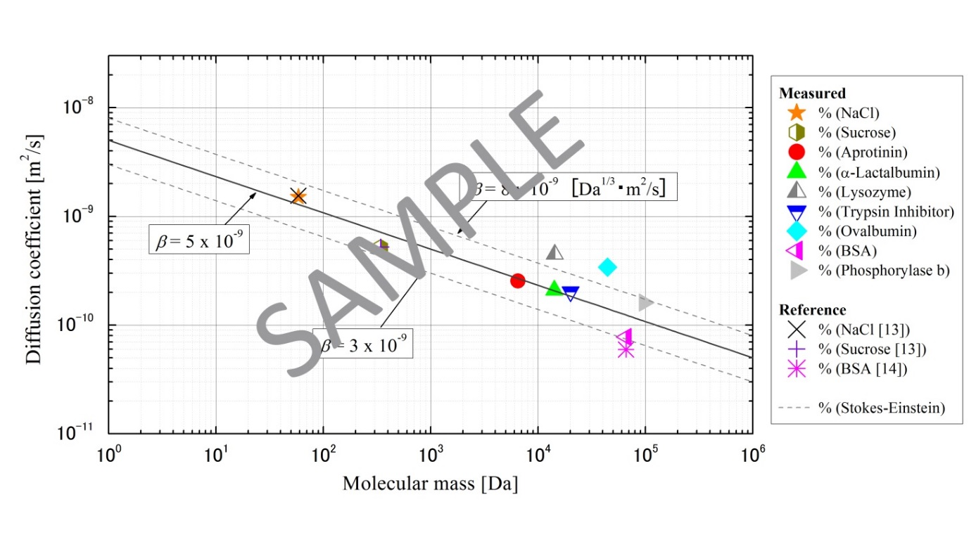
Fig. 1 One line figure captions are centered under the figure. Add 1 line space above the figure caption.

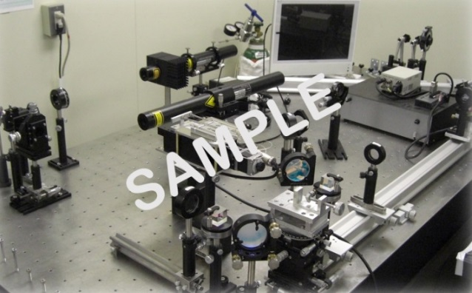

Fig. 2 Two or more lines are flushed left under the figure. Add a line space above the figure caption. Two or more lines are flushed left under the figure. Add 1 line space above the figure caption.

4.2 Tables When tables are mentioned in the text, they should be referred to as Table 1, Table 5, i.e., with a single letter space between the word “Table” and the Arabic numeral.

Table captions should appear above the respective table. Each table should have at least a two-line space both above the table and between the table and the start of the following text. The first letter of the word “Table” should be capitalized, followed by the table number and period, then the caption with the first letter of main words capitalized, all centered above the table as shown below. Use horizontal rules above and below to separate title from column heads, ranks within column heads, column heads from table body, and table body from table footnotes or source.

Tables are in Times New Roman, 11 pt. size type, of 1 line heading, centered, if 2 line heading flush left. The table caption goes above the table, with 1 line space above and below the caption. Type size of the body of the table depends on the size of the table, adjust type size accordingly.

Table 3 Table captions go above the table, captions that are 2 or more lines are flushed left, 1 line space above and below the caption.
Case | Diameter, (mm) | (Hz) | We | St
1 | 0.5 | 731 | 117 | 0.15
2 | 0.5 | 1799 | 620 | 0.16
3 | 1.3 | 198 | 124 | 0.17

5. NON-ENGLISH SPEAKING AUTHORS

Authors from non-English speaking countries are requested to find persons who are competent in English and familiar with the scientific language and can edit their manuscripts before submission. Reviewers may not be relied on to make corrections of English expression, spelling, etc. As there is no editing stage for publication-ready manuscripts, it is the responsibility of authors to ensure that the presentation of their extended abstracts reaches the same high level as that of the work they describe.

6. CONCLUSIONS

Paper Size and Length: A4 (210 × 297 mm) and 2-5 pages.
Margins: 20 mm margins all round as in the Full Paper Template.
Line Spacing: Single-spaced with one blank line between paragraphs. No paragraph indentation.
Justification: Full justification.
Page Numbering: Pages are to be numbered.
Graphs etc: Graphs, tables and photographs are to be included at the top or bottom of the page on which they are first mentioned if possible, on the next page if not, and not gathered together at the end of the extended abstract.
PDF transformation: Paper should be transformed to PDF file whose size is no more than 4 M byte, and sent to the International Scientific Committee via URL: http://prtec.submission.begellhouse.com/usr/login.html.
Submission Deadline: Extended abstract in PDF format for review should be submitted before September 30, 2015.

ACKNOWLEDGMENT

Acknowledgement should be placed immediately following CONCLUSIONS, if necessary.

NOMENCLATURE

The editors of all the major heat transfer journals have adopted a common list of symbols. All authors should use these symbols for extended abstract submitted for this symposium. A short nomenclature defining unusual or non-standard symbols should be placed immediately above the REFERENCES. The editors of all the major heat transfer journals have adopted a common list of symbols which authors are encouraged to use. Symbols which are defined in this list need not be included in the nomenclature list; only symbols unique to a particular project should be listed. The symbol list can be found in the Journal of Heat Transfer, Vol. 121, No. 4, pp. 770-773, November 1999.
SI Units must be used.

Be dimensionless variable ( - )
Ĉ second variable (s²)
Q_{A} third variable (kJ)
w_{x} fourth variable (m²/s)
ϕ(Ω) function
ζ dimensionless variable ( - )
Ω fifth variable ( s⁻¹ )

REFERENCES

Reference List at the end of the article should be numbered consecutively in the order they are mentioned, using Arabic numerals in square brackets [4] and formatted according to the following samples. Incorrectly formatted reference lists will be returned to the author for correction before acceptance. References should be in Times New Roman, 9 pt type size, justified copy, first line flush left, remaining lines indented (See Reference List Example).

[1] Guo, Z.Y., Zhu, H.Y., Liang, X.G., “Entransy - A physical quantity describing heat transfer ability,” Int. J. Heat Mass Transf., 50(13-14), pp. 2545-2556, (2007). Journal Paper
[2] Nield, D.A. and Bejan, A., Convection in Porous Media, New York: Springer-Verlag, pp. 125–176, (2005). Book
[3] Buyevich, A. and Alexandrov, D.V., Heat Transfer in Dispersions, Connecticut: Begell House, Available at http://www.edata-center.com/ebooks/b7f98f1e271b3e77a.html/ EBooks [accessed May 5, 2005] (2005). E-Books
[4] Yang, W. and Kim J.H. Eds., Rotating Machinery, New York: Begell House, (1992). Edited Book
[5] Nishikawa, K. and Ito, T., “Augmentation of Nucleate Boiling Heat Transfer by Prepared Surfaces,” In T. Mizushina and W.J. Yang, Eds., Heat Transfer in Energy Problems, Washington, D.C.: Hemisphere Publishing, pp. 111–1182, (1982). Chapters of Edited Book:
[6] Ma, T.M., “Effects of Geometrical Shapes of Reentrant Grooves on Boiling Heat Transfer from Porous Surfaces,” Heat Transfer 1986, Proc. of 8th Int. Heat Trans. Conf., vol. 4, pp. 2013–2018, (1987). Conference Proceedings
[7] Kasagi, N., Hasegawa, Y., Fukada, K. and Iwamoto, K., “Control of Turbulent Transport: Less Friction and More Heat Transfer,” Proc. of 13th Int. Heat Trans. Conf., IHTC14-23344, pp. 1-16, (2010). Conference Proceedings
[8] Richmond, J., Steady State Thermal Conductivity, Ph.D. Thesis, University of Connecticut, (2004). Dissertation
[9] Author, A.A. and Author, B.B., Title of document. Retrieved month day, year, from http://Web address, (Date of publication). Webpages: Nonperiodical Web Document
[10] Author, A.A. and Author, B.B. Title of article. In Title of book or larger document (chapter or section number). Retrieved month day, year, from http://www.someaddress.com/full/url/, (Date of publication). Chapter or Section of a Web document
[11] Author, A.A., & Author, B.B., “Title of article,” Title of Journal, volume number. Retrieved month day, year, from http://www.someaddress.com/full/url/, (Date of publication). Online Scholarly Journal Article

